Batch: A-3 Roll No.: 16010122104

Experiment / assignment / tutorial No. 5

Title: To develop UML diagrams for selected project
______________________________________________________________________
Aim: To learn and understand the way of creating various UML diagrams for requirement analysis
______________________________________________________________________

CO:
______________________________________________________________________

Books/ Journals/ Websites referred:
- Roger Pressman, “Software Engineering”, sixth edition, Tata McGraw Hill.
- System Analysis & Design by Satzinger, Jackson and Burd, Cengage Learning, 2007
- System Analysis and Design Methods by Jeffery l. Whitten, Lonnie D Bentley,McGraw Hill, 7th edition.
- System Analysis and Design by Alan Dennis, Barbara H. Wixom, Roberta M. Roth,Wiley India 4th edition
- http://en.wikipedia.org/wiki/Software_requirements_specification
- http://en.wikipedia.org/wiki/Use_case

__________________________________________________________________
Pre Lab/ Prior Concepts:
In software and systems engineering, a use case is a list of steps, typically defining interactions between a role (known in Unified Modeling Language (UML) as an "actor") and a system, to achieve a goal. The actor can be a human or an external system.
In systems engineering, use cases are used at a higher level than within software engineering, often representing missions or stakeholder goals. The detailed requirements may then be captured in Systems Modeling Language (SysML) or as contractual statements.
As an important requirement technique, use cases have been widely used in modern software engineering over the last two decades. Use case driven development is a key characteristic of process models and frameworks like Unified Process (UP), Rational Unified Process (RUP), Oracle Unified Method (OUM), etc. With its iterative and evolutionary nature, use case is also a good fit for agile development.
A sequence diagram is a graphical view of a scenario that shows object interaction in a time-based sequence of what happens first, what happens next.
Sequence diagrams establish the roles of objects and help provide essential information to determine class responsibilities and interfaces.

In UML, class diagrams are one of six types of structural diagram. Class diagrams are fundamental to the object modelling process and model the static structure of a system. Depending on the complexity of a system, you can use a single class diagram to model an entire system, or you can use several class diagrams to model the components of a system.

Class diagrams are the blueprints of your system or subsystem. You can use class diagrams to model the objects that make up the system, to display the relationships between the objects, and to describe what those objects do and the services that they provide.

In its basic form, an activity diagram is a simple and intuitive illustration of what happens in a workflow, what activities can be done in parallel, and whether there are alternative paths through the workflow. Activity diagrams as defined in the Unified Modeling Language are derived from various techniques to visually illustrate workflows. Activity diagrams are used to visualize the workflow of a business use case. A complete workflow description will have a basic flow, and one or several alternative flows. This workflow has a structure that we can define textually, using informal if, if-then-else, or does-until statements of various kinds. For a simple workflow with a simple structure such textual definitions may be quite sufficient, but in the case of more complex structures, activity diagrams help to clarify and make more apparent what the workflow is. Historically, activity diagramming techniques have mostly been used in the business process modeling domain, but this article will also briefly discuss how you can use it in the system modeling domain.

Requirement Modeling:
Significance of every diagram is to be written

- Use Case
Represents the functional requirements of a system by illustrating the interactions between external actors and the system’s main functionalities, helping to define what the system should do from the user's perspective.
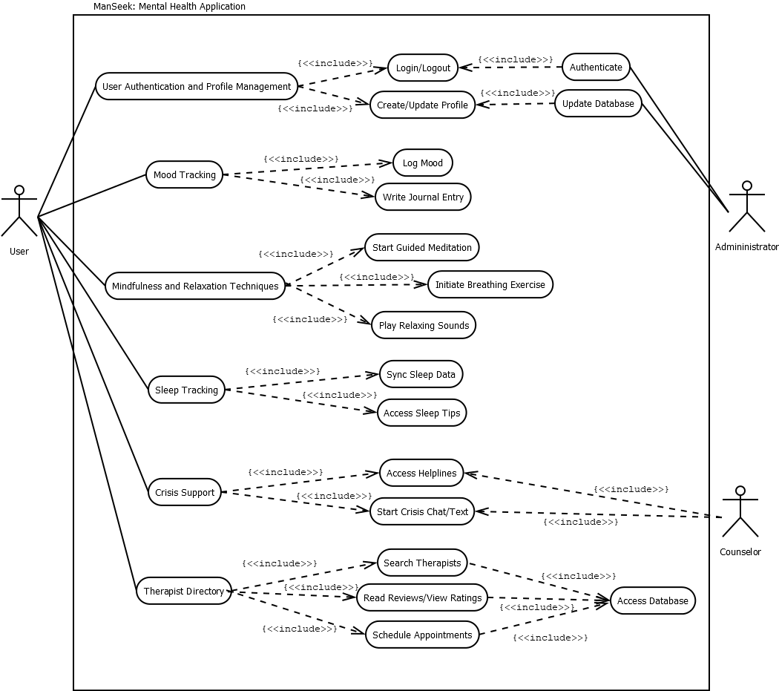

- Activity Diagram
Depicts the workflow and dynamic aspects of the system, showing the sequence of activities or processes, which helps to visualize the flow of control from one activity to another and identify decision points and parallel processes.
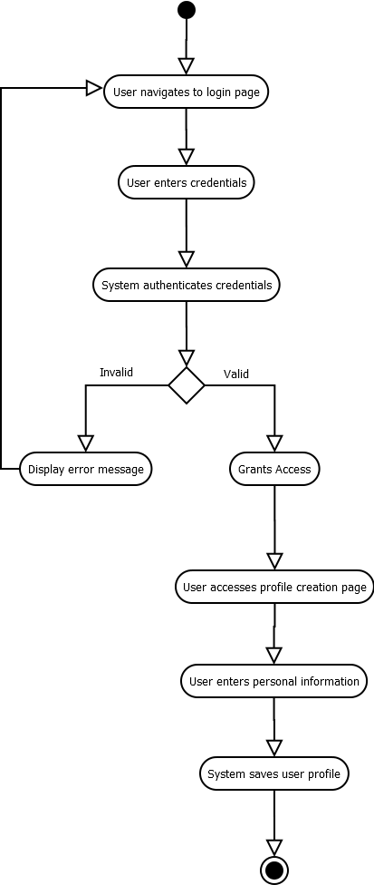
- Class Diagram
Defines the static structure of a system by illustrating the system’s classes, attributes, methods, and relationships, helping to outline the system’s data structure and object interactions for better design planning.
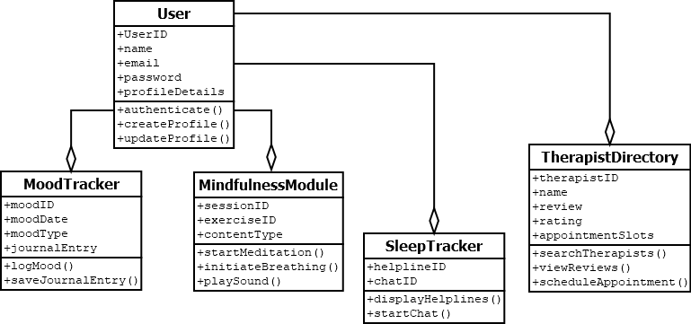
- Sequence
Shows the interaction between objects or components over time, highlighting the order of messages exchanged to achieve a specific function, which helps in understanding the timing and sequence of system operations.
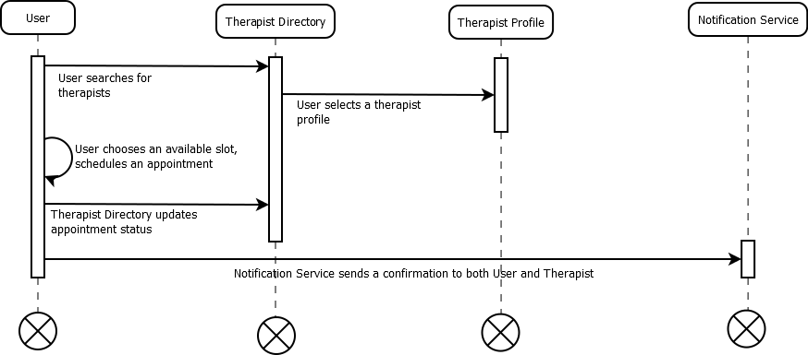

Virtual Lab Link: http://vlabs.iitkgp.ernet.in/se/7/
Virtual Lab Link: http://vlabs.iitkgp.ernet.in/se/3/exercise/
Virtual Lab Link: http://vlabs.iitkgp.ernet.in/se/5/exercise/
Virtual Lab Link: http://vlabs.iitkgp.ernet.in/se/6/

Conclusion:
UML diagrams like Use Case, Activity, Class, and Sequence provide a clear, structured visualization of system requirements, behavior, design, and interactions, aiding in effective communication, documentation, and system analysis throughout software development.

Post Lab Descriptive Questions:

- Where do use cases fit in the software development life cycle?
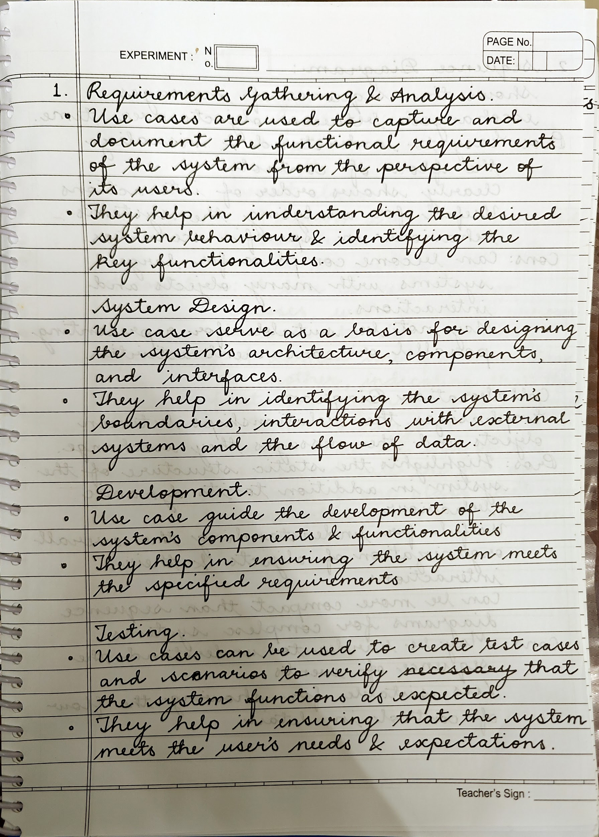
Ans:

- Compare sequence diagram with collaboration diagram. Explain pros and cons of each.
Ans:
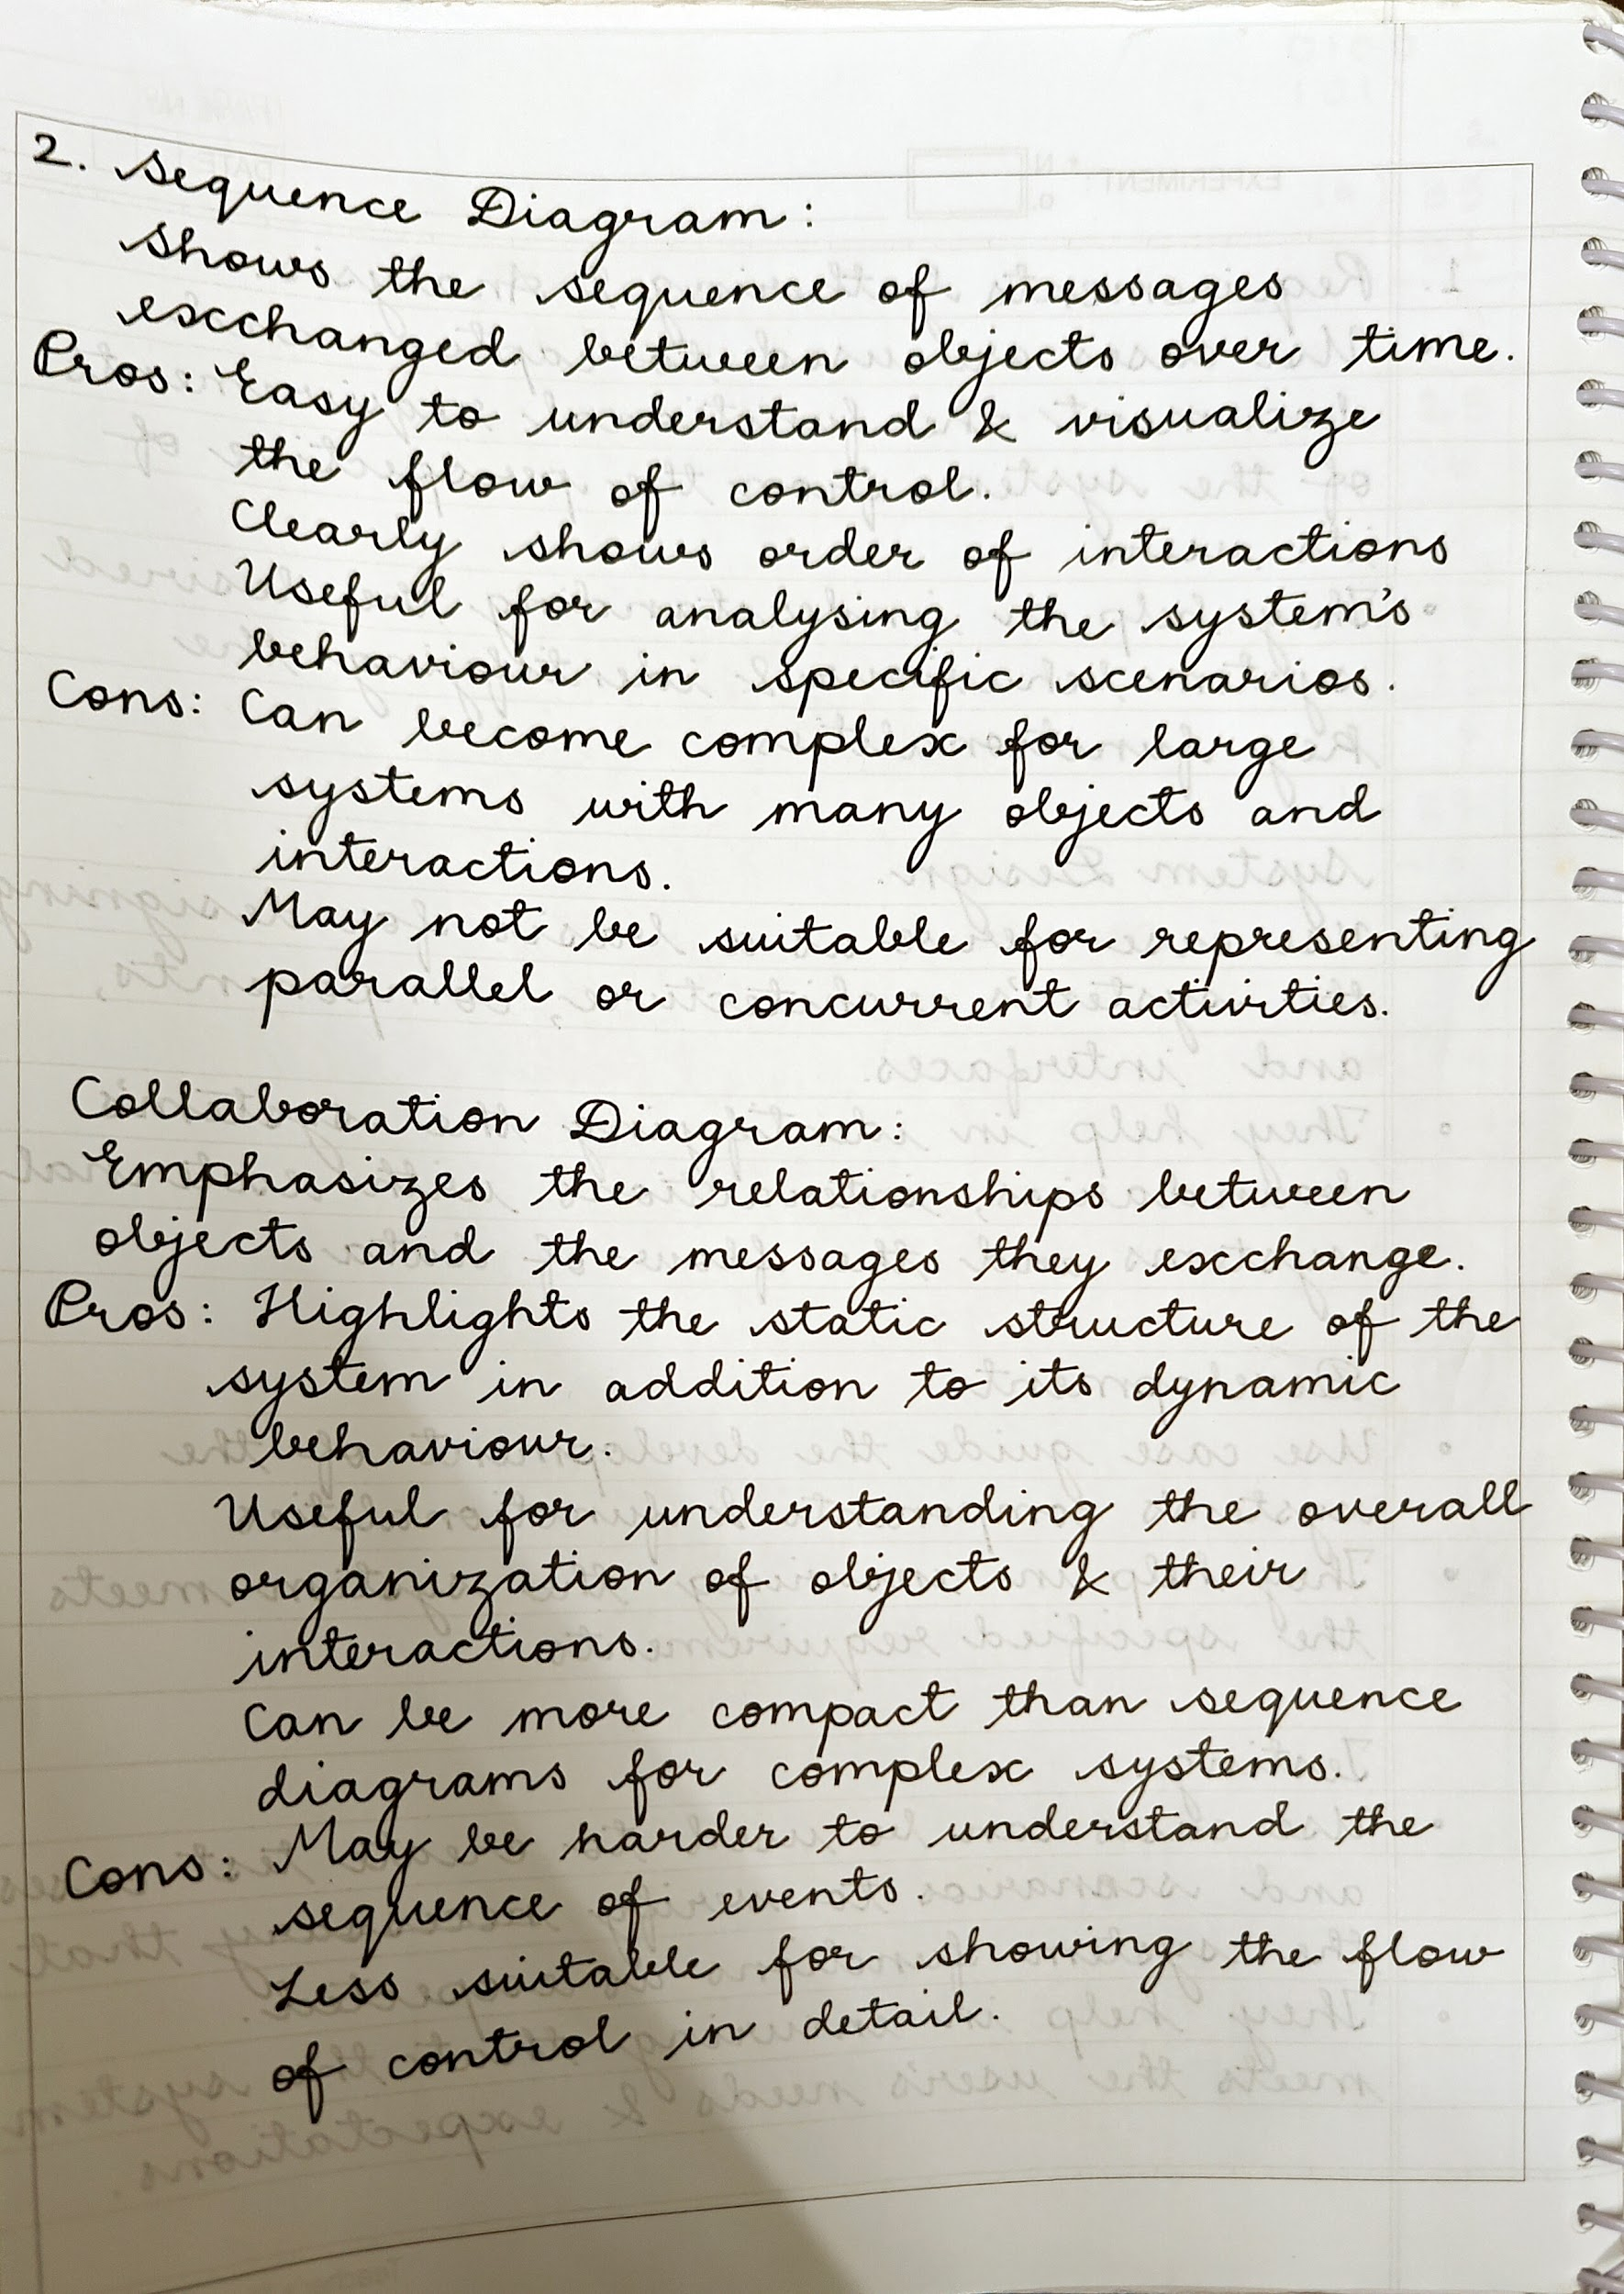

- List different notations used in Class diagram with example
Ans:
